Area-Preserving Rearrangement

Definition
# Source: AI Source: Provided by: [Data Path: Persons Table -> ID Column: 1, Name_En Column: Motasem Essam] -> From: [ChatGPT] on [7/25/2026]
Area-Preserving Rearrangement is a type of geometric figure rearrangement in which a figure is divided into pieces and those pieces are rearranged to form another figure while preserving the total area.
The pieces may be translated, rotated, reflected, or reordered, provided that the rearrangement does not add or remove area. For an exact dissection, the pieces must cover the final figure without gaps or overlapping interiors.

Simple Definition
# Source: AI Source: Provided by: [Data Path: Persons Table -> ID Column: 1, Name_En Column: Motasem Essam] -> From: [ChatGPT] on [7/25/2026]
Area-preserving rearrangement means rearranging geometric pieces to form a different figure with the same total area.

Example
# Source: AI Source: Provided by: [Data Path: Persons Table -> ID Column: 1, Name_En Column: Motasem Essam] -> From: [ChatGPT] on [7/25/2026]
A polygon is divided into smaller pieces and rearranged to form a rectangle. Although the outer shape changes, the total area remains the same.
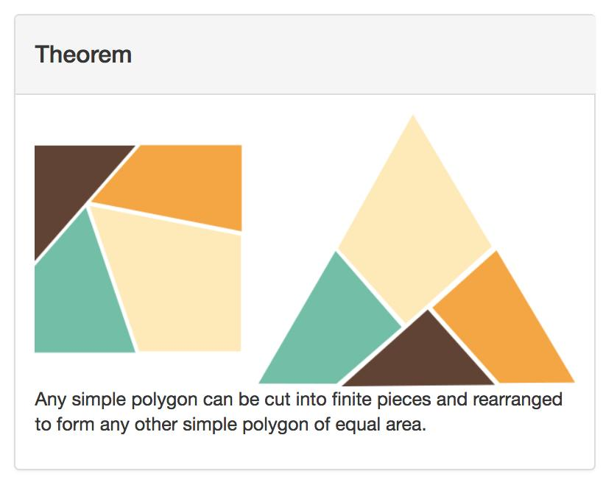

Main Classification of Area-Preserving Rearrangement
# Source: AI Source: Provided by: [Data Path: Persons Table -> ID Column: 1, Name_En Column: Motasem Essam] -> From: [ChatGPT] on [7/25/2026]
The following is a practical classification based on how area preservation is demonstrated. The categories can overlap and are not a universally standardized mathematical taxonomy.

1. Polygon-to-Rectangle Rearrangement
# Source: AI Source: Provided by: [Data Path: Persons Table -> ID Column: 1, Name_En Column: Motasem Essam] -> From: [ChatGPT] on [7/25/2026]
A polygon is divided into pieces that are rearranged to form a rectangle of equal area.
Example: An irregular polygon is dissected into triangular and rectangular pieces, which are rearranged into a rectangle.
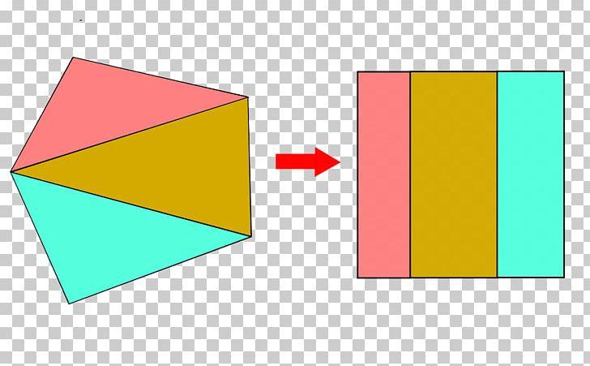

2. Triangle-to-Parallelogram Rearrangement
# Source: AI Source: Provided by: [Data Path: Persons Table -> ID Column: 1, Name_En Column: Motasem Essam] -> From: [ChatGPT] on [7/25/2026]
Triangular pieces are rearranged to form a parallelogram while preserving their combined area.
Example: Two congruent triangles are joined along corresponding edges to form a parallelogram.
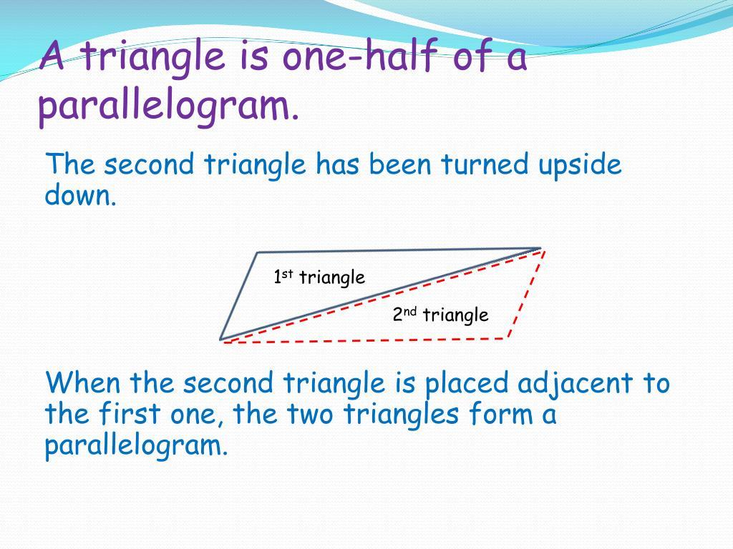

3. Parallelogram-to-Rectangle Rearrangement
# Source: AI Source: Provided by: [Data Path: Persons Table -> ID Column: 1, Name_En Column: Motasem Essam] -> From: [ChatGPT] on [7/25/2026]
A triangular section is cut from one side of a parallelogram and moved to the opposite side to create a rectangle.
Example: A parallelogram with base \(b\) and height \(h\) is rearranged into a rectangle with the same base and height.
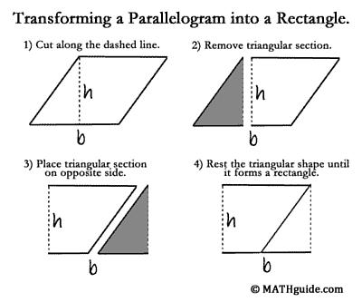

4. Trapezoid-to-Parallelogram Rearrangement
# Source: AI Source: Provided by: [Data Path: Persons Table -> ID Column: 1, Name_En Column: Motasem Essam] -> From: [ChatGPT] on [7/25/2026]
A trapezoid is divided or duplicated and its pieces are rearranged into a parallelogram to demonstrate an area relationship.
Example: Two congruent trapezoids are combined to form a parallelogram whose base is the sum of the trapezoid's parallel sides.
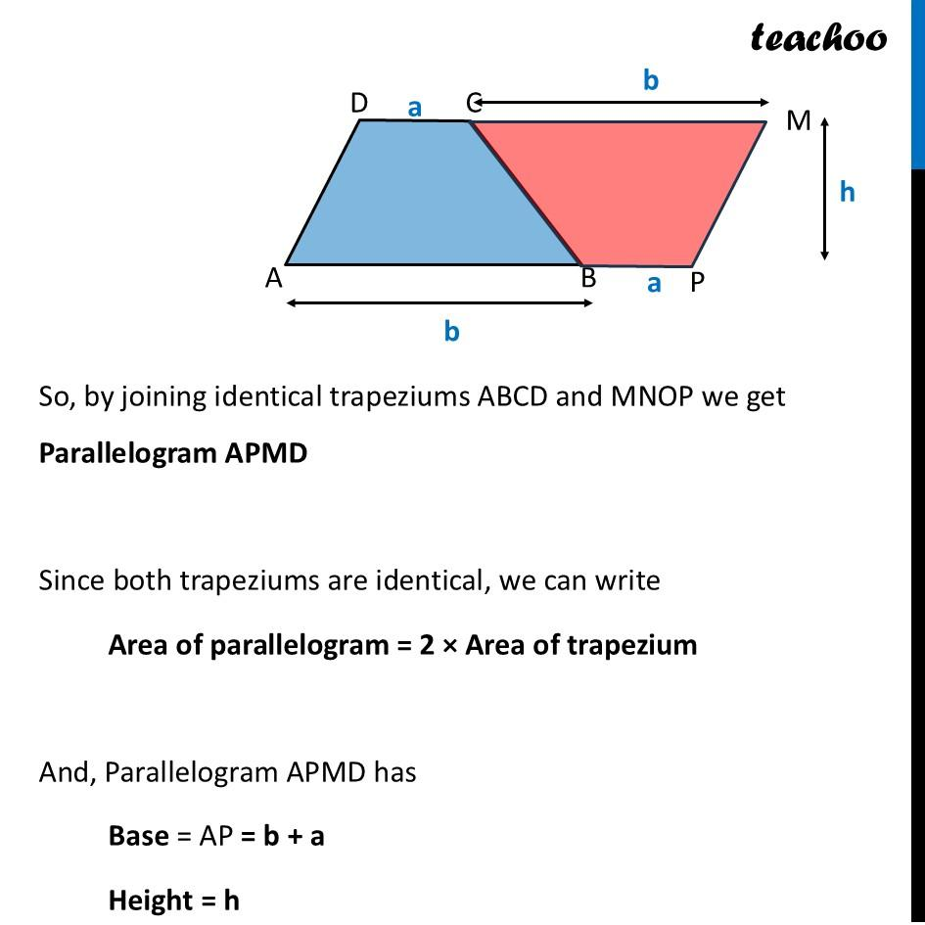

5. Polygon-to-Triangle Rearrangement
# Source: AI Source: Provided by: [Data Path: Persons Table -> ID Column: 1, Name_En Column: Motasem Essam] -> From: [ChatGPT] on [7/25/2026]
Pieces of a polygon are rearranged to form a triangle with the same total area.
Example: A polygon is dissected into triangles, and the triangular pieces are repositioned to form one larger triangle.
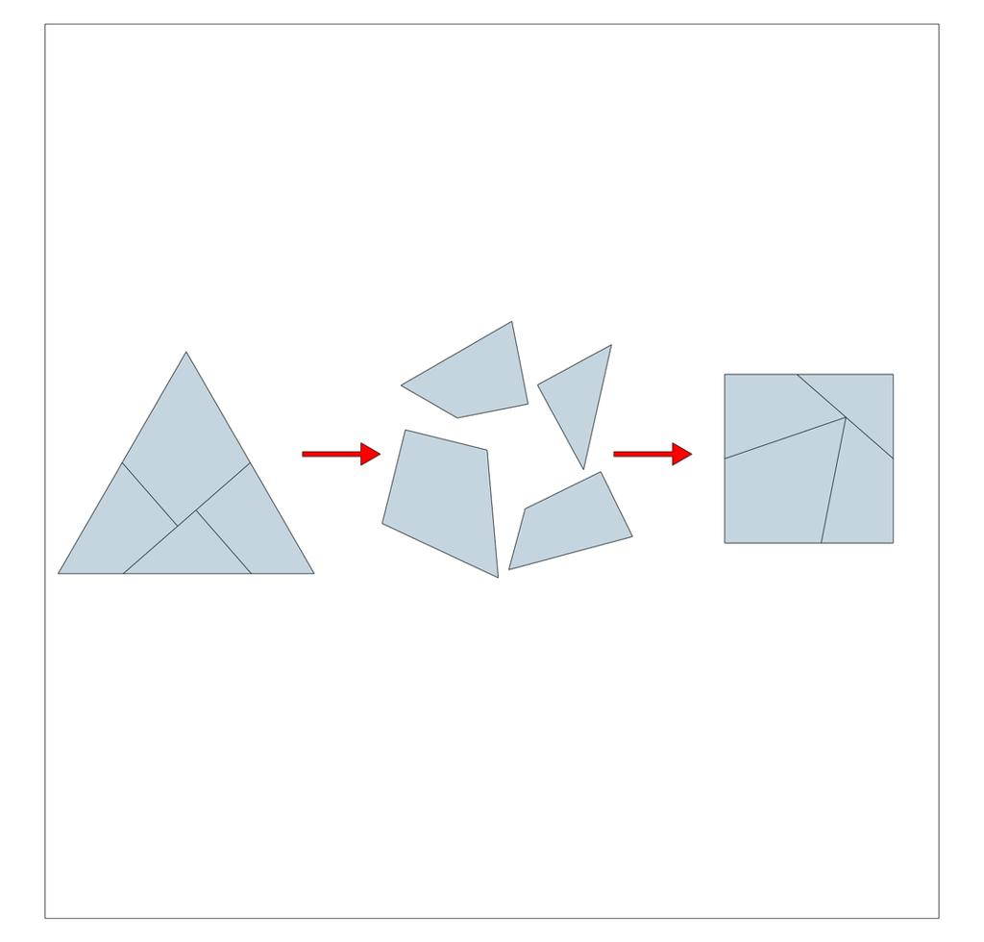

6. Square-to-Rectangle Rearrangement
# Source: AI Source: Provided by: [Data Path: Persons Table -> ID Column: 1, Name_En Column: Motasem Essam] -> From: [ChatGPT] on [7/25/2026]
A square is divided into pieces that can be rearranged into a rectangle with equal area.
Example: A square of side length $s$ is dissected into pieces and rearranged into a rectangle with dimensions $s^{2}/w$ and $w$, so the rectangle's area remains $s^{2}$.
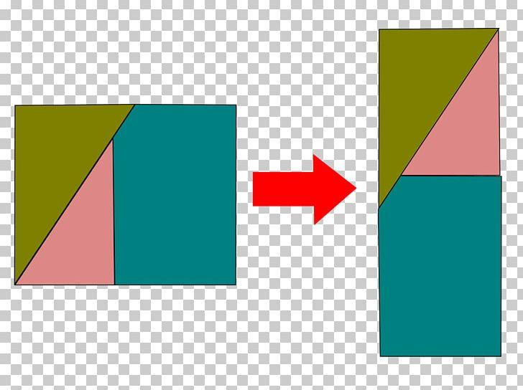

7. Rearrangement for Area Comparison
# Source: AI Source: Provided by: [Data Path: Persons Table -> ID Column: 1, Name_En Column: Motasem Essam] -> From: [ChatGPT] on [7/25/2026]
Two figures are dissected or rearranged to demonstrate that their areas are equal, even when their shapes differ.
Example: Two differently shaped polygons are divided into congruent pieces, showing that both have the same total area.
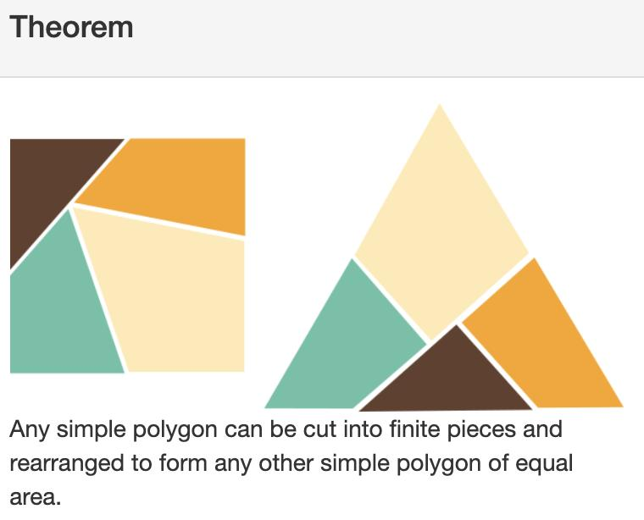

8. Dissection-Based Area-Preserving Rearrangement
# Source: AI Source: Provided by: [Data Path: Persons Table -> ID Column: 1, Name_En Column: Motasem Essam] -> From: [ChatGPT] on [7/25/2026]
A figure is cut into a finite collection of pieces, and the same pieces are rearranged to form a target figure.
Example: A polygon is dissected into several triangles and quadrilaterals that are assembled into a rectangle without gaps or overlapping interiors.
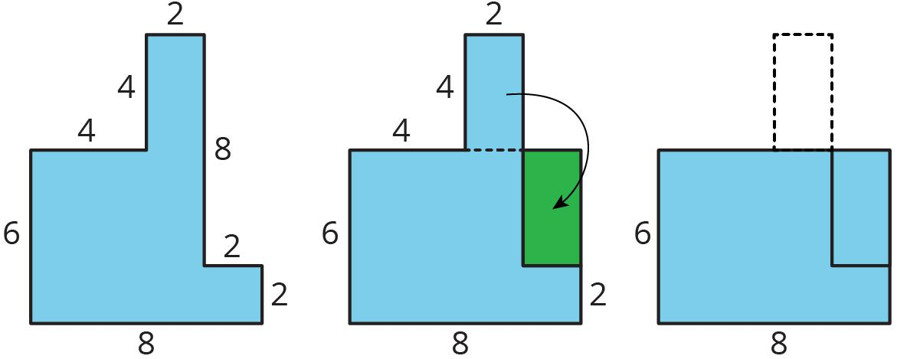

Mathematical Principle
# Source: AI Source: Provided by: [Data Path: Persons Table -> ID Column: 1, Name_En Column: Motasem Essam] -> From: [ChatGPT] on [7/25/2026]
Let a figure $F$ be divided into $n$ pieces:
$$F=P_{1}∪P_{2}∪⋯∪P_{n}$$
Suppose the same pieces are rearranged to form a new figure $G$:
$$G=P_{1}'∪P_{2}'∪⋯∪P_{n}'$$
If every piece retains its area and the pieces cover both figures exactly, then
$$\boxed{A\left(F\right)=A\left(G\right)}$$
Equivalently,
$$\boxed{A\left(F\right)=\sum_{i=1}^{n}{A}\left(P_{i}\right)=A\left(G\right)}$$
This is the fundamental principle of area-preserving rearrangement.

Detailed Mathematical Example
# Source: AI Source: Provided by: [Data Path: Persons Table -> ID Column: 1, Name_En Column: Motasem Essam] -> From: [ChatGPT] on [7/25/2026]
Consider a parallelogram with base $b=8$ units and perpendicular height $h=5$ units.
Its area is
$$A_{\text{parallelogram}}=bh$$
$$A_{\text{parallelogram}}=8\left(5\right)=40$$
Cut a triangular section from one end and move it to the opposite end to form a rectangle with the same base and height.
The rectangle's area is
$$A_{\text{rectangle}}=bh=8\left(5\right)=40$$
Therefore,
$$\boxed{A_{\text{parallelogram}}=A_{\text{rectangle}}=40}$$
The rearrangement changes the outer shape but preserves the total area.

Properties of Area-Preserving Rearrangement
# Source: AI Source: Provided by: [Data Path: Persons Table -> ID Column: 1, Name_En Column: Motasem Essam] -> From: [ChatGPT] on [7/25/2026]
- Area conservation: The total area remains unchanged.
- Piece preservation: The same pieces are used before and after rearrangement.
- Shape flexibility: The final figure may have a different shape from the original.
- Size flexibility: The overall dimensions and perimeter may change.
- Rigid-motion compatibility: Translation, rotation, and reflection preserve the area of each piece.
- Exact coverage: A valid dissection must cover the target without gaps or overlapping interiors.
- Area proof: Rearrangement can demonstrate area formulas and equal-area relationships.
- Perimeter variation: Equal-area figures do not necessarily have equal perimeters.

Area-Preserving Rearrangement vs. Related Concepts
# Source: AI Source: Provided by: [Data Path: Persons Table -> ID Column: 1, Name_En Column: Motasem Essam] -> From: [ChatGPT] on [7/25/2026]
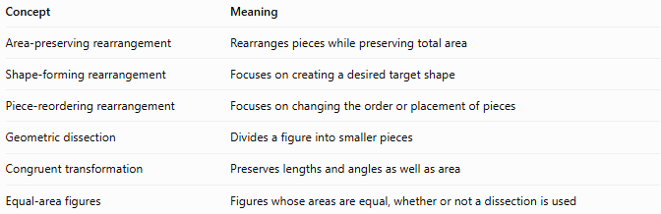
Concept | Meaning
Area-preserving rearrangement | Rearranges pieces while preserving total area
Shape-forming rearrangement | Focuses on creating a desired target shape
Piece-reordering rearrangement | Focuses on changing the order or placement of pieces
Geometric dissection | Divides a figure into smaller pieces
Congruent transformation | Preserves lengths and angles as well as area
Equal-area figures | Figures whose areas are equal, whether or not a dissection is used
Important distinction: Area preservation is a property of the rearrangement, whereas shape-forming describes its objective. A single rearrangement can be both area-preserving and shape-forming.

Classification Summary
# Source: AI Source: Provided by: [Data Path: Persons Table -> ID Column: 1, Name_En Column: Motasem Essam] -> From: [ChatGPT] on [7/25/2026]
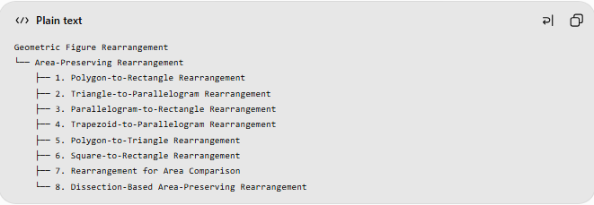
Geometric Figure Rearrangement
└── Area-Preserving Rearrangement
├── 1. Polygon-to-Rectangle Rearrangement
├── 2. Triangle-to-Parallelogram Rearrangement
├── 3. Parallelogram-to-Rectangle Rearrangement
├── 4. Trapezoid-to-Parallelogram Rearrangement
├── 5. Polygon-to-Triangle Rearrangement
├── 6. Square-to-Rectangle Rearrangement
├── 7. Rearrangement for Area Comparison
└── 8. Dissection-Based Area-Preserving Rearrangement
These are practical descriptive categories rather than mutually exclusive or universally standardized mathematical classes.

Key Points
# Source: AI Source: Provided by: [Data Path: Persons Table -> ID Column: 1, Name_En Column: Motasem Essam] -> From: [ChatGPT] on [7/25/2026]
- Area-preserving rearrangement demonstrates that different shapes can have equal areas.
- The total area remains unchanged when the same pieces are rearranged exactly.
- The perimeter and outer boundary may change even when the area does not.
- Dissection is a common method for proving area relationships geometrically.
- The method is useful in geometry education, area formulas, puzzles, and mathematical proofs.

Conclusion
# Source: AI Source: Provided by: [Data Path: Persons Table -> ID Column: 1, Name_En Column: Motasem Essam] -> From: [ChatGPT] on [7/25/2026]
Area-Preserving Rearrangement is a geometric method in which pieces of a figure are reorganized to form another figure of equal area. It provides a visual and mathematical way to demonstrate area equivalence without relying solely on algebraic formulas.

